**T.Y.B.Tech (CSE)**

System Software and Compilers(SSC)

**Lab Assignment No – 7**

**Name: Aniruddha Shende**

**Roll number: PD-05**

**Batch: D1**

**Panel: D**

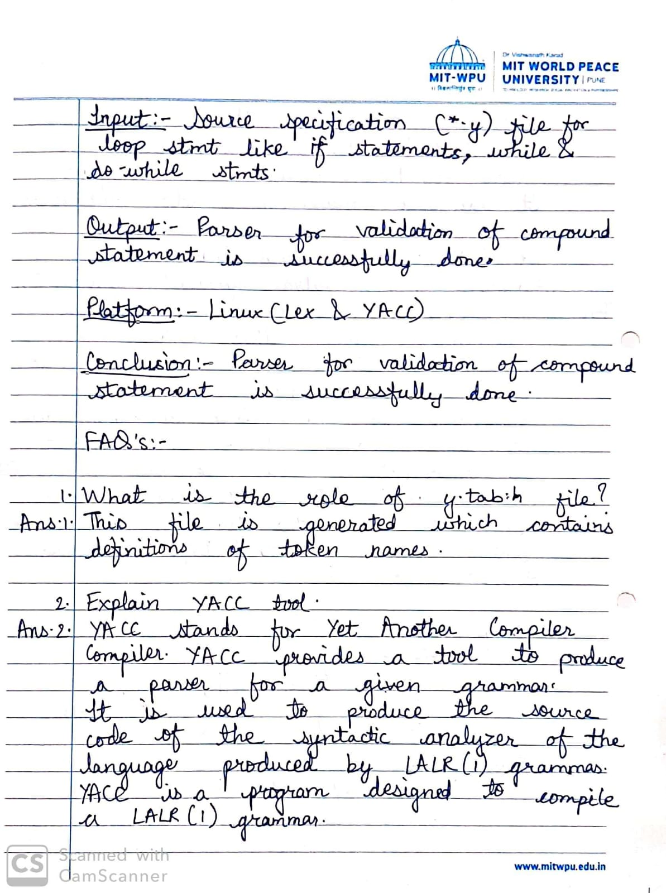

**Code & Output:**

**lab7.l :**

{%

include "y.tab.h"

extern int yyerror(char *str);

extern int yyparser();

%}

%%

"while" return WH;

"if" return IF;

"do" return DO;

"for" return FOR;

"(" return OP;

")" return CP;

"{" return OCB;

"}" return CCB;

"<" | ">" | "<=" | ">=" | "==" | "!=" return CMP;

"+" | "/" | "-" | "*" return OPR;

"=" return ASG;

([a-zA-Z])("_"|[a-zA-Z0-9])* return ID;

[0-9]+ return NUM;

";" return SC;

"," return COMMA;

" " {}

int yywrap(){

return 1;

}

**lab7.y :**

{%

#include<stdio.h>

extern int yylex();

extern int yywrap();

extern int yyparse();

%}

%token WH IF DO FOR OP CP OCB CCB CMP SC ADG ID NUM COMMA OPR

%%

start: swh | mwh | dowh | sif | mif;

swh: WH OP cmpn CP stmt {printf("VALID SINGLE STATEMENT WHILE LOOP\n");};

mwh: WH OP cmpn CP OCB stmt CCB {printf("VALID MULTI STATEMENT WHILE LOOP\n");};

dowh: DO OCB stmt CCB WH OP cmpn CP SC {printf("VALID DO-WHILE LOOP\n");};

sid: IF OP cmpn CP stmt {printf("VALID SINGLE STATEMENT IF\n");};

mif: OF OP cmpn CP OCB stmt CCB {printf("VALID MULTIPLE STATEMENT IF");};

cnob: ID CMP ID | ID CMP NUM;

stmt: ID ASG ID OPR ID SC | ID ASG ID OPR NUM SC | ID ADG NUM OPR ID SC | ID ADG NUM OPR NUM SC | ID ASG NUM | start {printf("NESTED INSIDE A ");}

%%

int yyerror(char *str) {

printf("%s", str);

}

main() {

yyparse();

}

**Output:**

